School Plan for Shared

Student Achievement

**What is it?**

This is a plan that describes how Wheeless Road Elementary will

provide opportunities to improve parent engagement to support

student learning.

Wheeless Road Elementary values the contributions and involvement of

parents to establish an equal partnership for the common goal of improving

student achievement. This plan describes the different ways that Wheeless

Road Elementary will support parent engagement and how parents can help

plan and participate in activities and events to promote student learning at school

and at home.

**How is it revised?**

Wheeless Road Elementary School invited all parents to attend an input/revision meeting to review and revise this parental involvement policy, as well as the school-wide plan, our school-parent compact and the parental involvement budget. Additionally, parent input and comments regarding this plan are welcome during the school year through an online form. The plan is posted on our school Web site for parents to view and submit feedback throughout the year. All parent feedback received during the year will be used to revise the plan for the next school year. We also distribute an annual survey to ask parents for their suggestions on the plan and the use of funds for parental involvement. Parents can also give feedback during several parent meetings and activities during the school year.

**Who is it for?**

All students participating in the Title I, Part A program, and their families, are encouraged and invited to fully participate in the opportunities described in this plan. Wheeless Road Elementary will provide full opportunity for the participation of parents with limited English, parents with disabilities and parents of migratory children.

**Where is it available?**

At the beginning of the year, the plan is shared with parents via the input/revision meeting and the Annual meeting. The plan will also be posted on the school Web site. Parents can also retrieve a copy of the plan in the Parent Resource Center.

**Wheeless Road Elementary School**

***Parental Involvement Policy and Plan for Shared Student Success***

***2025-2026 School Year***

***Mr. Carl Robinson III, Principal***

***2530 Wheeless Rd.***

***Augusta, Ga. 30906***

***(706) 796-4985***

*Wheeless.rcboe.org*

***Revised August 12th, 2025***

**What is Title I?**

Wheeless Road Elementary is identified as a Title I school as part of the Elementary and Secondary Education Act of 1965 (ESEA). Title I is designed to support State and local school reform efforts tied to challenging state academic standards in reinforce and enhance efforts to improve teaching and learning for students. Title I programs must be based on effective means of improving student achievement and include

strategies to support parental

involvement. All Title I schools

must jointly develop with all

parents a written parental

involvement policy.

2025–2026 District Goals

**Student Achievement**

* **During The 25-26 school year, we will increase student content mastery in tested subject areas on the Georgia Milestones by 6%.**
* **During the 25-26 school year, we will increase post-high school readiness by increasing our graduation rate by 2%.**

**Talent Development**

* **During 25-26 school year, we will increase teacher and support staff retention by 3% through consistent, meaningful employee feedback & evaluations.**

**Safe & Secure Learning Environment**

* **During the 25-26 school year, we will improve the on-time delivery rate of student transportation services by 5%.**
* **During the 25-26 school year, we will reduce chronic absenteeism by 3%.**

2025–2026 School Goals

**1. Teacher will participate in weekly collaborative planning to increase student content mastery to 80%.**

**2. Students scoring proficient on EOY**

**I-Ready will increase by 25% in math and reading.**

**3. Increase our school climate rating by May 2026, from 2 to 3, by implementing strategies to improve staff morale.**

**Let’s Get Together!**

**Annual Title1 Meeting- September 12th, 2025**

We invite you to a meeting, learning and sharing about our

Title1 program including our parent and family engagement policy,

the school wide plan, the school parent compact and parent requirements.

Invites will come by flyers, DOJO, Shout Outs, or School Sign.

**Progress Report #1- September 12th 2025**

**Fall Parent Conference Window – September 15th to October 10th 2025**

**Progress Report #2 – October 31st 2025**

**American Education Week – November 17-21st 2025**

**Parental Involvement Day- November 2025**

Come join your student for lunch

**Report Card #1 – January 13th 2026**

Spring Semester Progress Report #1 – February 12th 2026

**Spring Semester Progress Report #2 – March 27th 2026**

**Report Card #2 – May 27th 2026**

*****Notice will be given for all other upcoming event

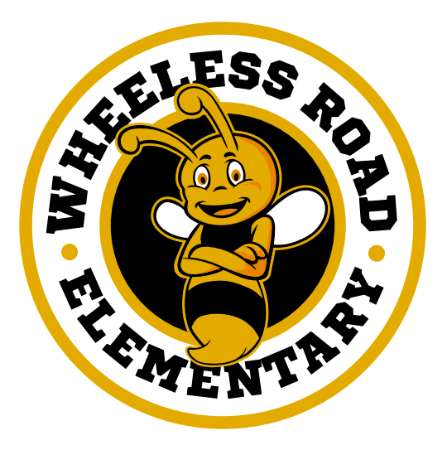

School-Parent Compacts

As part of this plan, Wheeless Road Elementary and our families will develop a school-parent compact, which is an agreement that parents, teachers, and students will develop that explains how parents and teachers will work together to make sure all our students reach grade-level standards. The compacts will be reviewed and updated annually based on

feedback from parents, students

and teachers during the

parent involvement events

and the School Forum.

The school-parent

compacts are kept

with each child’s

teacher if parents

need a copy.

**Parent Resource Center**

Come visit the Parent Resource Center to check out books, study materials, and activities to use at home with your child. Computers are available for parents to explore the Parent Portal and educational resources.

Days and Times: Monday-Friday 10am to 2:00pm

Location: Room 191

Wheeless Road Elementary is committed to

helping our parents participate in the parental

activities listed in this plan. Please call or

email us if you have any questions/concerns

or issues regarding attending meetings.

(Parent Coordinator) Joe Willis

(706) 796-4985 ext. 6219

Parental Involvement

Wheeless Road Elementary believes that parental involvement means the participation of parents in regular two-way, and meaningful communication involving student academic learning and other school activities, including ensuring:

* That parents play an integral role in assisting their child’s learning.
* That parents are encouraged to be actively involved in their child’s education at school.
* That parents are full partners in their child’s education and are included, as appropriate, in decision-making and on advisory committees to assist in the education of their child.
* The carrying out of other activities as described in this plan.

**Wheeless Road Elementary is Branching Out!**

Wheeless Road Elementary will take the following measures to promote and support parents as an important foundation of the school in order to strengthen the school and reach our school goals. We will:

* Ensure that all information related to school and parent programs, meetings, and other activities is published in both English and Spanish, posted on the school Web site, and included in the monthly school newsletter for all parents.
* Provide parents information in a timely manner about Title I and the rights of parents to be involved. Provide written notice to all parents in regard to the identification WRES is a Title 1 School Improvement school. Use SHOUT Point messaging system, flyers and post events on the Website to invite all parents to meetings and encourage them to attend.
* Share information in English and Spanish on the school Website and in the school newsletter for parents to understand the school’s academic standards and assessments as well as the ways parents can monitor their child’s progress and work with educators.
* Communicate with all families and the community on a regular basis regarding school-wide events and activities, through phone messages, school website DOJO and flyers.
* Work with our parents to develop relevant trainings and helpful presentations to educate our staff on the importance of parental involvement.
* Provide necessary materials and handouts for parents at conferences, meetings, and activities to help parents work with their child to improve their child’s achievement.
* Collect feedback from parents at all events in order to respond to parents’ requests for additional support for parental involvement activities.



**Share Your Thoughts**

We want to hear from you. If you have any suggestions or if there is any part of this plan that you feel is not satisfactory with the students’ and the school’s goals for academic achievement, please provide us with your comments in the space provided and leave this form in the Main Office:

Name: (optional)



Telephone Number: (optional)



